**Practical 8**

1. Write a jQuery to check the contents of the elements on the button click.

<!DOCTYPE html>

<head>

<title>**Basic jQuery**</title>

<script src=**"jquery-3.6.1.min.js"**></script>

<script>

$**(**document**).**ready**(*function*** **()** **{**

$**(**"#btn"**).**click**(*function*(){**

document.write**(**"Hello Romal"**)**

**})**

**})**

</script>

</head>

<body>

<p>**Romal: 239720**</p>

<button id=**"btn"**>**Click Me**</button>

</body>

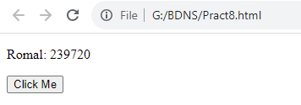

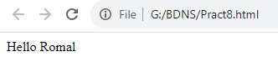

1. Write a jQuery to select elements by class name, id and element names.

<!DOCTYPE html>

<head>

<title>**Basic jQuery**</title>

<script src=**"jquery-3.6.1.min.js"**></script>

<script>

$**(**document**).**ready**(*function*()** **{**

$**(**".class1"**).**css**(**"background"**,**"lightblue"**);**

$**(**"#id1"**).**css**(**"background"**,**"pink"**);**

$**(**"h2"**).**css**(**"background"**,** "lightgreen"**);**

**})**

</script>

</head>

<body>

<p class=**"class1"**>**Romal: 239720**</p>

<p id=**"id1"**>**Romal Shah**</p>

<h2>**Welcome Romal**</h2>

</body>

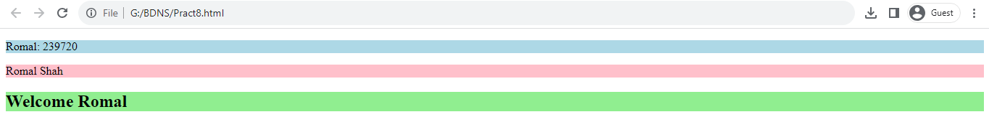

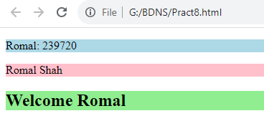

1. Write jQuery to show the use of click(), hover(), on(), trigger(),off() events.

<!DOCTYPE html>

<head>

<title>**Basic jQuery**</title>

<script src=**"jquery-3.6.1.min.js"**></script>

<script>

$**(**document**).**ready**(*function*** **()** **{**

$**(**"#b1"**).**hover **(*function*(){**

document.write**(**"Hello Romal"**)**

**})**

$**(**"p"**).**on**(**"click"**,** ***function*()** **{**

$**(*this*).**css**(**"background"**,** "yellow"**);**

**});**

$**(**"#b2"**).**click**(*function*(){**

$**(**"p"**).**off**(**"click"**);**

**});**

$**(**"#b3"**).**on**(*function*(){**

$**(**"#t1"**).**hide**();**

**});**

$**(**"input"**).**select**(*function*(){**

$**(**"input"**).**after**(**"Text Marked!"**)**

**});**

$**(**"#b4"**).**click**(*function*(){**

$**(**"input"**).**trigger**(**"select"**);**

**});**

**})**

</script>

</head>

<body>

<button id=**"b1"**>**Hover**</button><br>

<p>**Welcome to the Mulund College**</p><br>

<p>**Romal: 239720**</p><br>

<button id=**"b2"**>**Off**</button><br>

<p id=**"t1"**>**Hello Romal**</p><br>

<button id=**"b3"**>**On**</button><br>

<input type=**"text"** value=**"Romal 239720"**><br>

<button id=**"b4"**>**Trigger**</button><br>

</body>

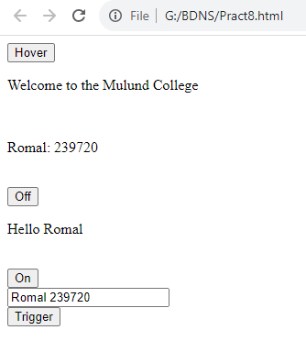

Hover:

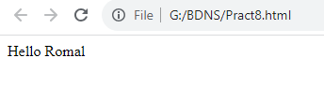

Click, on, off

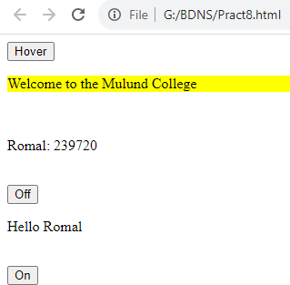

Trigger:



1. Write a jQuery to create animated show hide effect.

<!DOCTYPE html>

<head>

<title>**Basic jQuery**</title>

<script src=**"jquery-3.6.1.min.js"**></script>

<script>

$**(**document**).**ready**(*function*(){**

$**(**"#b1"**).**click**(*function*(){**

$**(**"p"**).**hide**();**

**});**

$**(**"#b2"**).**click**(*function*(){**

$**(**"p"**).**show**();**

**})**

**})**

</script>

</head>

<body>

<p>**Romal Shah:239720**</p>

<button id=**"b1"**>**Hide**</button>

<button id=**"b2"**>**Show**</button>

</body>

.

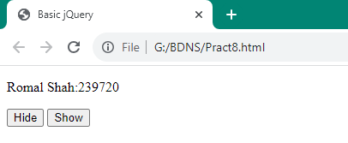

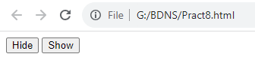

1. Write a jQuery to create a simple toggle effect.

<!DOCTYPE html>

<head>

<title>**Basic jQuery**</title>

<script src=**"jquery-3.6.1.min.js"**></script>

<script>

$**(**document**).**ready**(*function*(){**

$**(**"button"**).**click**(*function*(){**

$**(**"p"**).**toggle**();**

**});**

**})**

</script>

</head>

<body>

<p>**Romal Shah:239720**</p>

<button>**Toggle**</button>

</body>

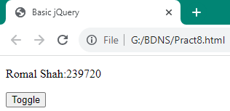

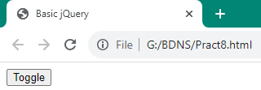

1. Write a jQuery to create fade-in and fade-out effect.

<!DOCTYPE html>

<head>

<title>**Basic jQuery**</title>

<script src=**"jquery-3.6.1.min.js"**></script>

<script>

$**(**document**).**ready**(*function*(){**

$**(**".c1"**).**click**(*function*(){**

$**(**"p"**).**fadeOut**(**5000**);**

**});**

$**(**".c2"**).**click**(*function*(){**

$**(**"p"**).**fadeIn**(**5000**);**

**})**

**})**

</script>

</head>

<body>

<p>**Romal Shah:239720**</p>

<button class=**"c1"**>**Fade Out**</button>

<button class=**"c2"**>**Fade In**</button>

</body>

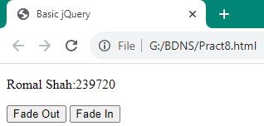

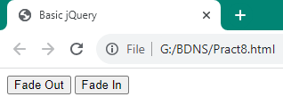

1. Write a jQuery to create fade toggle effect.

<!DOCTYPE html>

<head>

<title>**Basic jQuery**</title>

<script src=**"jquery-3.6.1.min.js"**></script>

<script>

$**(**document**).**ready**(*function*(){**

$**(**"button"**).**click**(*function*(){**

$**(**"p"**).**fadeToggle**(**5000**);**

**});**

**})**

</script>

</head>

<body>

<p>**Romal Shah:239720**</p>

<button>**Fade Toggles**</button>

</body>

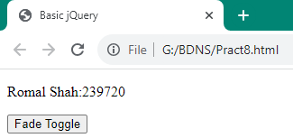

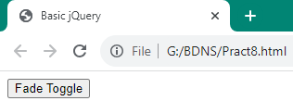

1. Write a jQuery to create slide-up and slide-down effect.

<!DOCTYPE html>

<head>

<title>**Basic jQuery**</title>

<script src=**"jquery-3.6.1.min.js"**></script>

<script>

$**(**document**).**ready**(*function*(){**

$**(**"#b1"**).**click**(*function*(){**

$**(**"p"**).**slideUp**(**3000**);**

**});**

$**(**"#b2"**).**click**(*function*(){**

$**(**"p"**).**slideDown**(**3000**);**

**})**

**})**

</script>

</head>

<body>

<p>**Romal Shah:239720**</p>

<button id=**"b1"**>**Slide Up**</button>

<button id=**"b2"**>**Slide Down**</button>

</body>

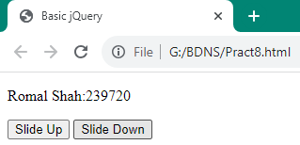

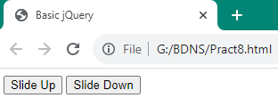

1. Write a jQuery to create slide toggle effect.

<!DOCTYPE html>

<head>

<title>**Basic jQuery**</title>

<script src=**"jquery-3.6.1.min.js"**></script>

<script>

$**(**document**).**ready**(*function*(){**

$**(**"button"**).**click**(*function*(){**

$**(**"p"**).**slideToggle**(**5000**);**

**})**

**})**

</script>

</head>

<body>

<p>**Romal Shah:239720**</p>

<button>**Slide Toggle**</button>**s**

</body>

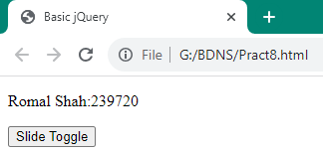

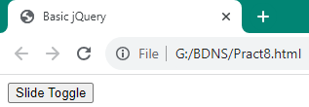

1. Write a jQuery to create Mouse Event.

<!DOCTYPE html>

<html>

<head>

<title>**Basic jQuery**</title>

<script src=**"jquery-3.6.1.min.js"**></script>

<script>

$**(**document**).**ready**(*function*(){**

$**(**"#p1"**).**mouseleave**(*function*(){**

alert**(**"Bye! You now leave p1"**);**

**})**

**})**

</script>

</head>

<body>

<p id=**"p1"**>**This is a paragraph**</p>

</body>

</html>

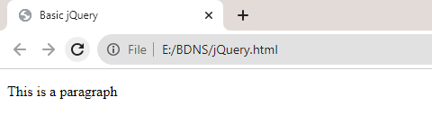

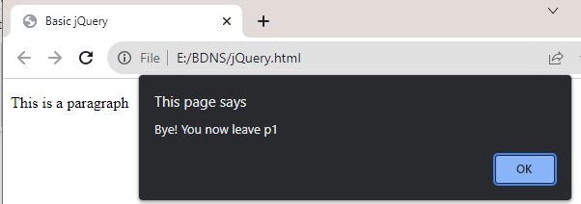

**Practical 9**

1. Write a jQuery to create animation effect.

<!DOCTYPE html>

<head>

<title>**Basic jQuery**</title>

<script src=**"jquery-3.3.1.min.js"**></script>

<script>

$**(**document**).**ready**(*function*(){**

$**(**"button"**).**click**(*function*(){**

$**(**"img"**).**animate**({**left**:**50**});**

**})**

**})**

</script>

<style>

**img{position:relative;}**

</style>

</head>

<body>

<p>**Romal:239720**</p>

<img src=**"Mountain.png"** alt=**"Mountain Image"**><br>

<br><button>**Start Animation**</button>

</body>

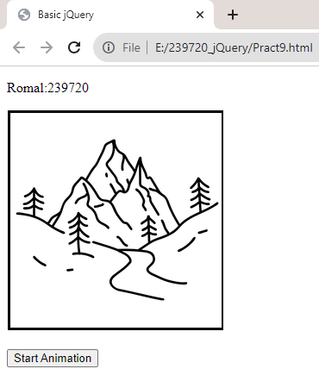

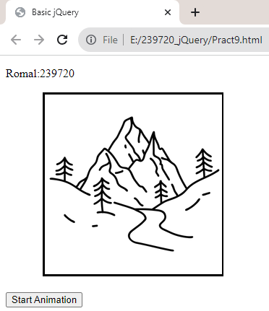

1. Write a jQuery to animate multiple css properties.

<html>

<head>

<script src=**"jquery-3.6.1.min.js"**></script>

<script>

$**(**document**).**ready**(*function*(){**

$**(**"#b1"**).**click**(*function*(){**

$**(**"#div1"**).**animate**({**width**:**"150px"**,**height**:**"150px"**,**opacity**:**"0.5"**,**left**:**"150"**});**

**})**

**})**

</script>

<style>

**#div1{width:100px;height:100px;background:yellow;position:relative;}**

</style>

</head>

<body>

<p> **Animation**</p>

<div id=**"div1"**></div>

<button id=**"b1"**>**Click to Animate**</button>

</body>

</html>

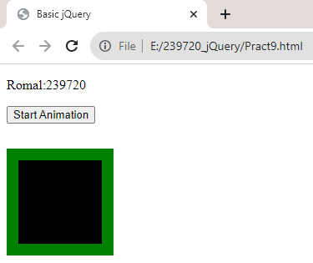

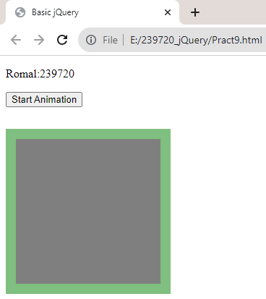

1. Write a jQuery to perform method of chaining.

<!DOCTYPE html>

<head>

<title>**Basic jQuery**</title>

<script src=**"jquery-3.3.1.min.js"**></script>

<script>

$**(**document**).**ready**(*function*(){**

$**(**"button"**).**click**(*function*(){**

$**(**"#p1"**).**css**(**"color"**,**"blue"**).**slideUp**(**2000**).**slideDown**(**2000**)**

**})**

**})**

</script>

</head>

<body>

<p id=**"p1"**>**Romal:239720**</p>

<button>**Click Me**</button>

</body>

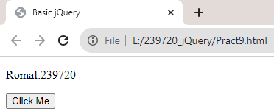

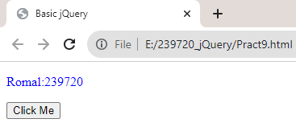

1. Write a jQuery effect method with a callback function.

<!DOCTYPE html>

<head>

<title>**Basic jQuery**</title>

<script src=**"jquery-3.3.1.min.js"**></script>

<script>

$**(**document**).**ready**(*function*(){**

$**(**"button"**).**click**(*function*(){**

$**(**"p"**).**hide**(**"slow"**,function(){**

alert**(**"The paragraph is now hidden"**)**

**})**

**})**

**})**

</script>

</head>

<body>

<p>**Romal:239720**</p>

<p>**Welcome to MCC**</p>

<button>**Click!**</button>

</body>

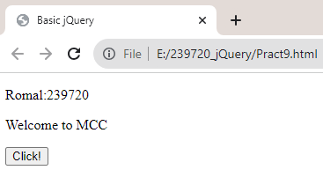

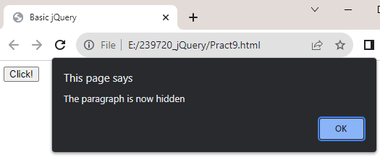

1. Write a jQuery to get and set text context of the elements.

<!DOCTYPE html>

<head>

<title>**Basic jQuery**</title>

<script src=**"jquery-3.6.1.min.js"**></script>

<script>

$**(**document**).**ready**(function(){**

$**(**"#b1"**).**click**(function(){**

**var** str **=** $**(**"p"**).**text**();**

alert**(**str**);**

**})**

$**(**"#b2"**).**click**(function(){**

$**(**"p"**).**text**(**"Hello World"**);**

**})**

**})**

</script>

</head>

<body>

<p>**Romal Shah:239720**</p>

<p> **MongoDB**</p>

<button id=**"b1"**>**Get**</button>

<button id=**"b2"**>**Set**</button>

</body>

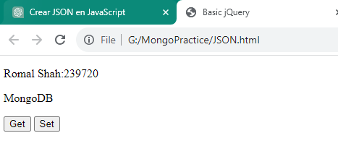

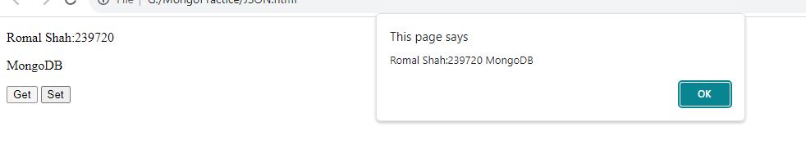

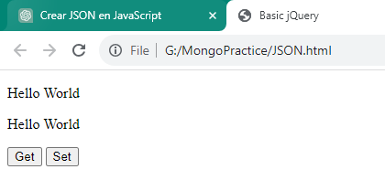

1. Write a jQuery to get and set HTML contents of the elements.

<!DOCTYPE html>

<head>

<title>**Basic jQuery**</title>

<script src=**"jquery-3.6.1.min.js"**></script>

<script>

$**(**document**).**ready**(*function*(){**

$**(**"#b1"**).**click**(*function*(){**

***var*** str **=** $**(**"p"**).**html**();**

alert**(**str**);**

**})**

$**(**"#b2"**).**click**(*function*(){**

$**(**"p"**).**html**(**"<b>Hello World<b>"**);**

**})**

**})**

</script>

</head>

<body>

<p><b>**Romal Shah:**</b><u>**239720**</u></p>

<p> **MongoDB**</p>

<button id=**"b1"**>**Get**</button>

<button id=**"b2"**>**Set**</button>

</body>

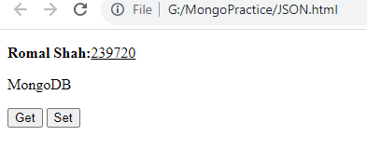

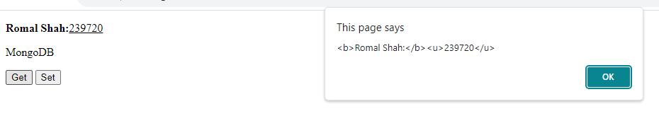

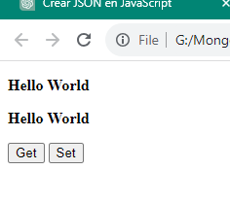

**10. JSON**

Creating JSON

<html>

<head>

<title>**Creating JSON**</title>

</head>

<body>

<script type=**"text/javascript"**>

**var** data**={**

"name"**:**"Romal"**,**

"age"**:**20**,**

"dept"**:**"IT"

**}**

document.writeln**(**JSON.stringify**(**data**)+**"</br>"**);**

document.writeln**(**JSON.stringify**(**data**,[**"name"**,**"age"**,**"dept"**])+**"<br/>"**);**

document.writeln**(**JSON.stringify**(**data**,[**"name"**,**"age"**,**"dept"**],**5**));**

</script>

</body>

</html>

Output:

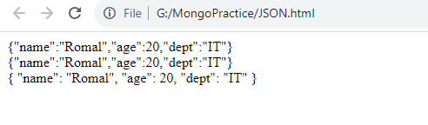

Parsing JSON

<html>

<body>

<script type=**"text/javascript"**>

***var*** data **=** '{"name":"Romal","age":20,"dept":"IT"}'**;**

***var*** jsonObj **=** JSON.parse**(**data**,** ***function*(**name**,** value**)** **{**

***return*** value**;**

**});**

document.writeln**(**jsonObj.name**);**

***for*** **(**key ***in*** jsonObj**)** **{**

document.writeln**(**"<br/>" **+** key **+** " : " **+** jsonObj**[**key**]);**

**}**

***var*** jsonObj **=** JSON.parse**(**data**,** ***function*(**name**,** value**)** **{**

***if*** **(**name **==** "sem"**)** **{**

***return*** undefined**;**

**}** ***else*** **{**

***return*** value**;**

**}**

**});**

***for*** **(**key ***in*** jsonObj**)** **{**

document.writeln**(**"<br/>" **+** key **+** " : " **+** jsonObj**[**key**]);**

**}**

</script>

</body>

</html>

Output:

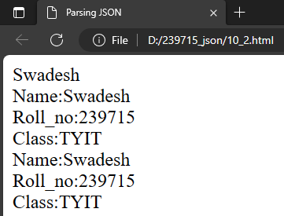

3.

<html>

<body>

<script type=**"text/javascript"**>

**var** data **=** '{"name":"Romal","age":20,"dept":"IT"}'**;**

**var** obj **=** JSON.parse**(**data**);**

**for(var** key **in** obj**)**

**{**

document.writeln**(“<br/>+”**key**+**":"**+**obj**[**key**]);**

**}**

</script>

</body>

</html>

Output:

